
Company
Logotype

Cone Beam Computed Tomography- Report



Porur Dental X-rays & CBCT

Patient Name : Mr. Sasidhar | Date of Report : 05.07.2024
Age/ Gender : 45 years/ Male | Region of Interest : CBCT Mandible
Referring doctor: Dr. R. Aravindhan | Indication : Implant assessment
Clinical Notes: Nil
PATIENT INFORMATION

CBCT- Mandible provided
CBCT – IMAGE DETAILS

RADIOGRAPHIC INTERPRETATION

- Complete loss of crown and root structure in relation to 37.
- The alveolar bone in relation to 37 is present with normal trabecular pattern.
- In relation to the apical region of mesial root presence of a diffuse irregular sclerotic region evident.

IMPLANT ASSESSMENT

 | 37 region
Sub-Crestal (in mm) | 6.72
Mid- Crestal (in mm) | 9.7
Distance between alveolar ridge and the inferior alveolar nerve canal (in mm) | 12.72
Distance between alveolar ridge and the inferior border of mandible (in mm) | 24.66

RADIOGRAPHIC IMPRESSION

- Partially edentulous region: 37.
- Idiopathic osteosclerosis: mesial root of 38.

Kindly correlate with clinical findings


IMAGES FOR REFERENCE

RECONSTRUCTED PANORAMIC VIEW

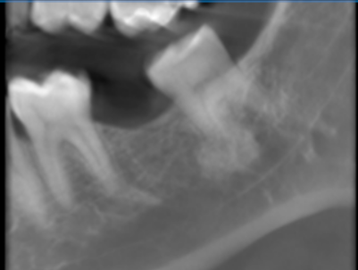

3-DIMENSIONAL VIEW

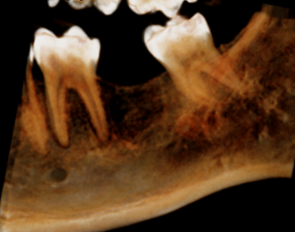

CROSS SECTIONAL VIEW

37 region | 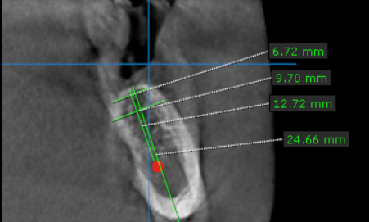

**** End of report ****

